**Philips Color Kinetics**

Vaya Manufacturing Tool

User Guide

**Ref. Established for Supply Chain Management**

If this procedure is a printed hard copy, verify revision before use

|  |  |  |  |
| --- | --- | --- | --- |
| **Revision** | **Date** | **Author** | **Description of Change** |
| 00 | July-22-2014 | Simon He | First Release |
|  |  |  |  |
|  |  |  |  |

Table of Contents

1 Introduction 3

2 Environment Setup 3

2.1 PC Setup 3

2.1.1 Install Drivers 3

2.1.2 Launch the tool 3

2.2 2.2 Hardware Setup 3

2.2.1 2.2.1 Connect the signal wire and power cable 3

3 Configuration Function Descriptions 4

3.1 Enter the Operator ID 4

3.2 Connect Smart Jack Pro 5

3.3 Setting the Parameter 5

4 Addressing Function Descriptions 6

4.1 Discover 6

4.2 Change DMX Address and Device Label 6

4.3 Export Report 7

5 Test and Play Function Descriptions 7

5.1 Fixed Color 7

5.2 Color Wash 7

5.3 Channel Test 7

6 Info 8

# Introduction

Vaya Configuration Tool is designed for parameters configuration and fixture test during manufacturing from Philips Solid-State Lighting Solutions.

Together with Smart Jack Pro, it can be set up a test and configure station for Philips Vaya Series Lighting Fixture which compatible with RDM and DMX protocol.

This tool has below features:

1. Generate the first UID of the day.

2. Set fixture UID and model description based on Vaya Profile file and Production Factory.

3. Simple test for testing the communication station on the RS485 bus.

4. Discover the UID and fixture information which connected on the bus and generate report.

5. Fixed Color Test.

6. Color Wash Test.

7. Single Channel Test.

# Environment Setup

## PC Setup

### Install Drivers

1. Copy the entire software folder to your target folder.
2. Plug-in the USB cable to your computer and the Smart Jack Pro
3. If the operation system doesn’t recognize the hardware, then install the driver in Data🡪FTDI Driver Folder

### Launch the tool

The software is green software. You can launch the tool by double click the icon.

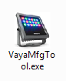

## 2.2 Hardware Setup

### 2.2.1 Connect the signal wire and power cable

Please refer to the sketch to connect the wire. Be careful with the color.

On Smart Jack Pro, D+ is Orange and D- is Orange/White. While on the fixture, D+ is Orange/White and D- is Orange.

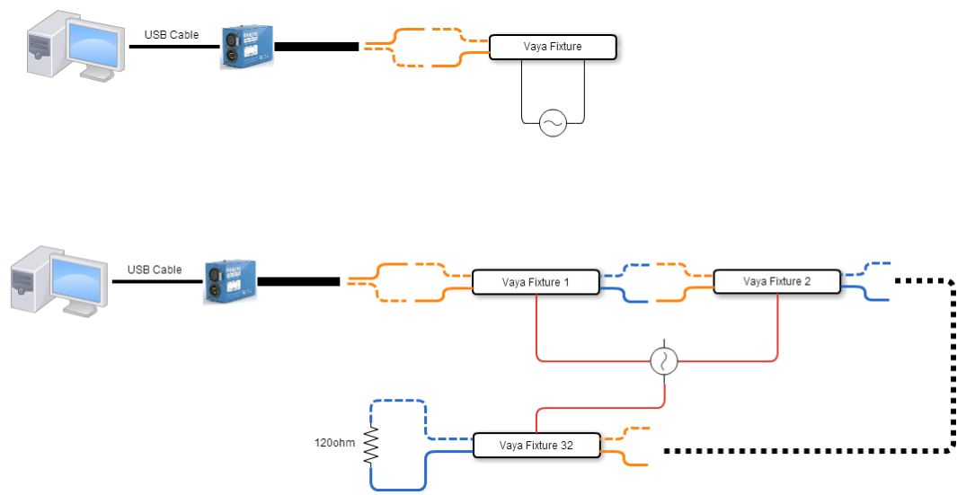

# Configuration Function Descriptions

## Enter the Operator ID

When launch the tool, you have to enter the operator ID. The ID will be record in the log file.

And the ID will display on the top side of the main window.

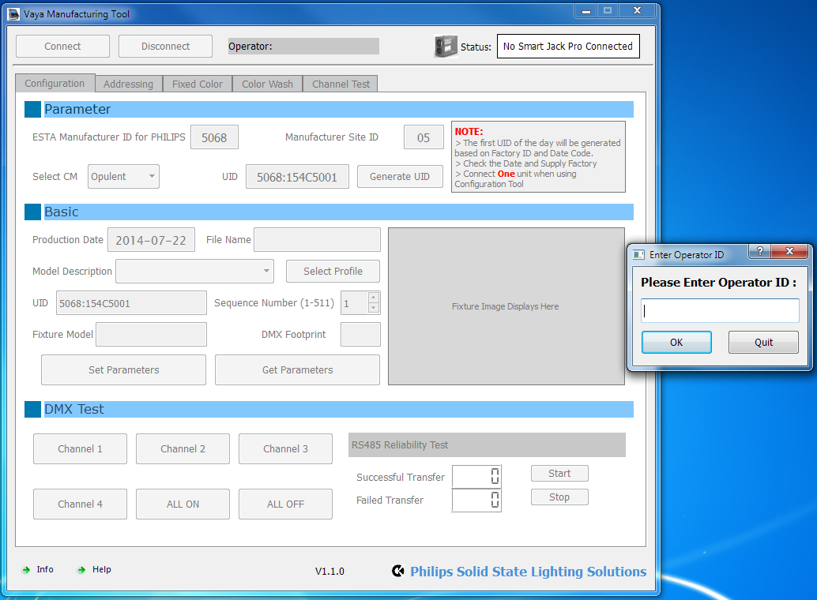

## Connect Smart Jack Pro

You will connect the SJP first in order to use the function of this tool.

When the SJP is properly connected to the computer, click Connect button. If the device connected successfully, the icon on the right will display with color and SJP’s Serial number will be displayed.

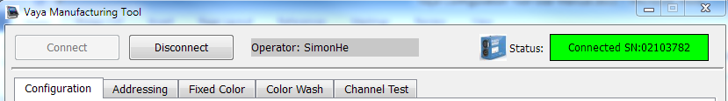

If the connection failed, you need to check the USB cable status or if device driver is installed correctly.

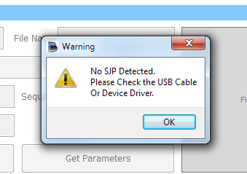

You can click the Disconnect button to release the SJP from the software. All the functions in the tool will be disabled.

## Setting the Parameter

All the parameter is set in Configuration Tab. And this function only allow to be used when connect one fixture.

In the Parameter Section, you can select the CM (Factory your fixture produce). The UID will auto-generate when you select the CM. Others information is fixed which correspondent to Philips.

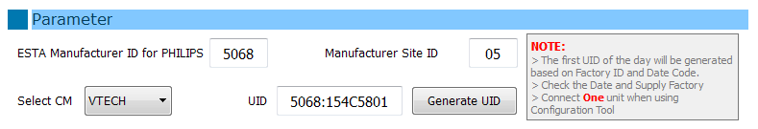

In Basic Section, Click the Select Profile Button to choose the profile file which comes along with your product. (This file is given by the engineer from Philips. If you don’t know the version of this file, please contact Philips for further information.)

After select the correct Profile file, information will display on each box. These are defined in the file and cannot be changed.

Input the corresponding UID in to the UID box and Click the Set Parameters. Check the pop-up dialog to see whether the parameters are successfully set into the fixture.

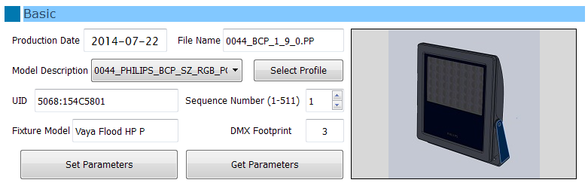

After set, you can read back the information by click Get Parameters button.

And you can perform a basic test of the fixture by using the buttons in DMX Test Section

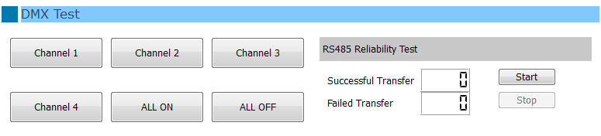

# Addressing Function Descriptions

## Discover

When there is more than one fixture connected on the RS485 bus, you can use Discover function to read back the UID and some other information of these fixtures.

On the Addressing Tab, click Discover button, the software will enter the process to discover the fixtures which connect to the SJP via RS485 bus. After few seconds (Depends on the number of the fixtures), the discovered fixtures will be listed in the table. By click the Clear button, you can empty the table.

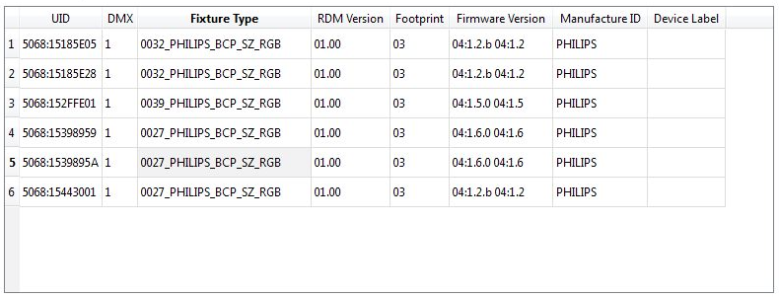

In the table, there are UID, DMX start address, Fixture type, RDM version, Footprint, Firmware version, Manufacture ID and Device label. When you choose one row of the fixtures, you can identify it. The selected fixture will blink with 1s interval.

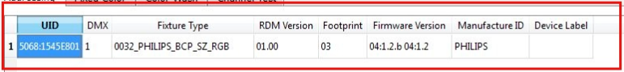

If the fixture type AND firmware version of this fixture is matched to the Profile, the fixture image will display on the bottom left box. Otherwise, the image will not display.

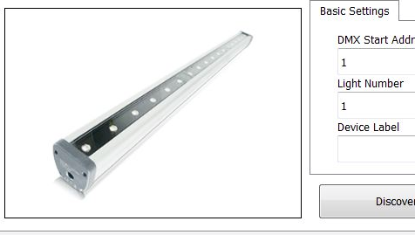

## Change DMX Address and Device Label

You can modify the DMX Start Address, Light Number and Device Label in this section.

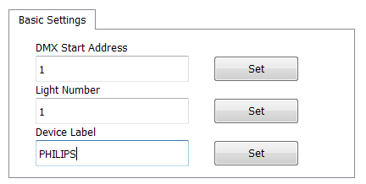

## Export Report

Click Export Report button to generate Discover report (.XLS Format). And located at Report Folder.

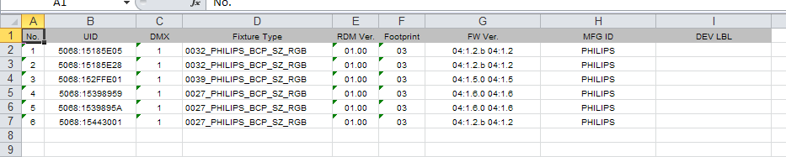

# Test and Play Function Descriptions

## Fixed Color

For testing color, you can choose the color on the Gamut region in Fixed Color Tab. You can pick and drag the color, if the fixture works normally, the color output will be the same with the color you pick.

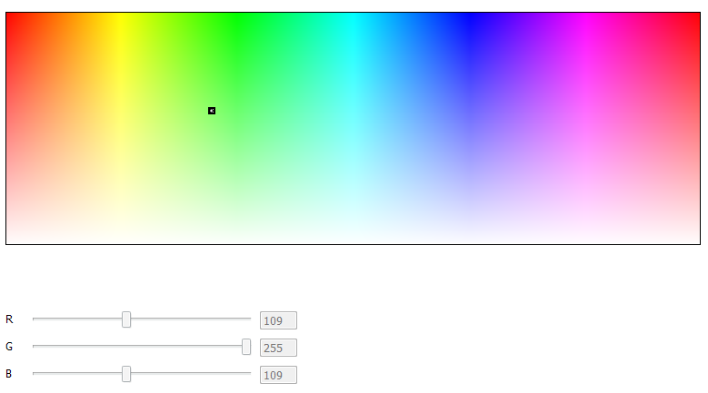

## Color Wash

In Color Wash Tab, Click Start will begin the Color Wash effect. You can change the cycle changing time from 1S to 30S.

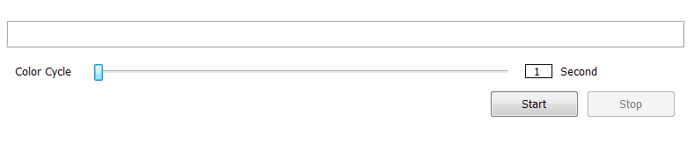

## Channel Test

DMX signal will occupy 512 DMX address. In Channel Test Tab, you can single select or multiple select channel, the channel you select will output if the fixture works properly.

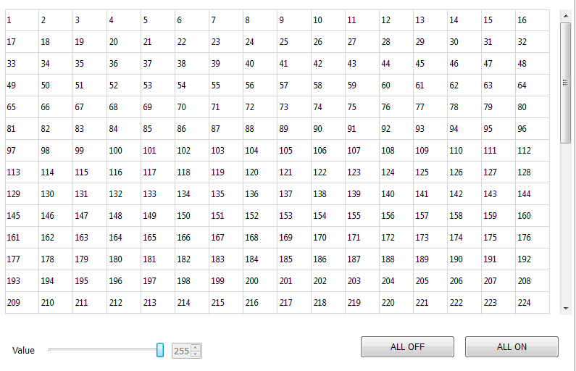

# Info

The info dialog will show the software version and supporting contact for this tool.

